Hands-on 1 - Spring Data JPA – Quick Example

Name: Shubham Sangram Bej

Aim
To develop a Spring Boot application using Spring Data JPA and Hibernate that connects to a MySQL database, maps a database table to a Java entity, retrieves data using a repository and service layer, and displays the retrieved records through the main application.

Software Requirements
- IntelliJ IDEA Community/Ultimate Edition
- Java JDK 21
- Spring Boot 3.5.x
- Maven
- MySQL Server 8.0
- MySQL Workbench 8.0

Theory
Spring Data JPA is a Spring Framework module that simplifies database operations by reducing the amount of boilerplate code required for data access. It provides repository interfaces with built-in CRUD operations and integrates seamlessly with Hibernate, which acts as the JPA implementation.
Spring Boot simplifies application configuration by automatically configuring the required dependencies and database connectivity. Using annotations such as @Entity, @Table, @Repository, @Service, and @Transactional, developers can create a layered application architecture that separates the entity, repository, service, and application logic. Hibernate maps Java objects to relational database tables, allowing developers to work with objects instead of writing SQL for common database operations.

Objectives
- Create a Spring Boot project using Maven.
- Configure MySQL database connectivity.
- Create a Country entity mapped to the database table.
- Create a JPA Repository for database operations.
- Implement a Service layer.
- Retrieve all country records from the MySQL database.
- Verify successful execution using Spring Boot logging.

Procedure
- Created a Spring Boot Maven project using Spring Initializr.
- Added Spring Data JPA, MySQL Driver, and Spring Boot DevTools dependencies.
- Configured MySQL connection properties in application.properties.
- Created the ormlearn database in MySQL.
- Created the country table.
- Inserted sample records (IN and US) into the table.
- Created the Country entity class using JPA annotations.
- Created the CountryRepository interface by extending JpaRepository.
- Implemented CountryService with a transactional method to retrieve all countries.
- Modified OrmLearnApplication to obtain the service bean and display the retrieved data.
- Executed the application and verified successful retrieval of country records.

Project Structure
HandsOn1SpringDataJpaQuickExample
│
├── src
│ ├── main
│ │ ├── java
│ │ │ └── com.cognizant.ormlearn
│ │ │ ├── model
│ │ │ │ └── Country.java
│ │ │ ├── repository
│ │ │ │ └── CountryRepository.java
│ │ │ ├── service
│ │ │ │ └── CountryService.java
│ │ │ └── OrmLearnApplication.java
│ │ │
│ │ └── resources
│ │ └── application.properties
│ │
│ └── test
│
├── Screenshots
├── pom.xml
└── .gitignore

Output
The application successfully connected to the MySQL database, retrieved the records stored in the country table using Spring Data JPA, and displayed the following output in the console:
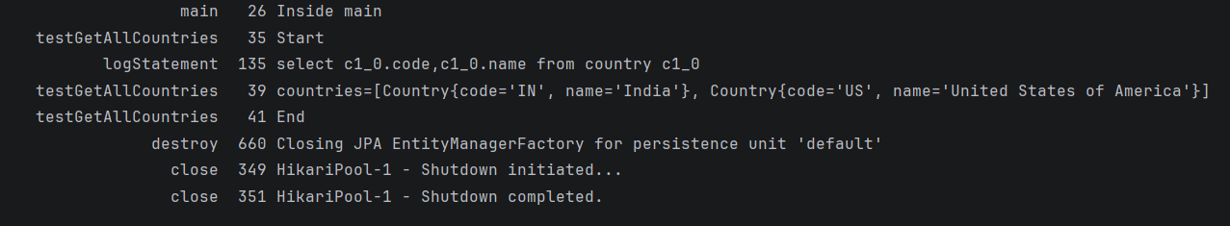

Result
The Spring Boot application was successfully developed using Spring Data JPA and Hibernate. The application established a connection with the MySQL database, mapped the country table to the Country entity, retrieved all records through the repository and service layers, and displayed the results successfully.

Conclusion
This hands-on demonstrated the implementation of Spring Data JPA with Spring Boot for database interaction using Hibernate. It illustrated how entity mapping, repository interfaces, and service-layer architecture simplify data access while reducing boilerplate code. The successful retrieval of country records from MySQL confirmed the correct integration of Spring Boot, Hibernate, and Spring Data JPA, providing a strong foundation for developing database-driven enterprise applications.

Screenshots
- Project Structure
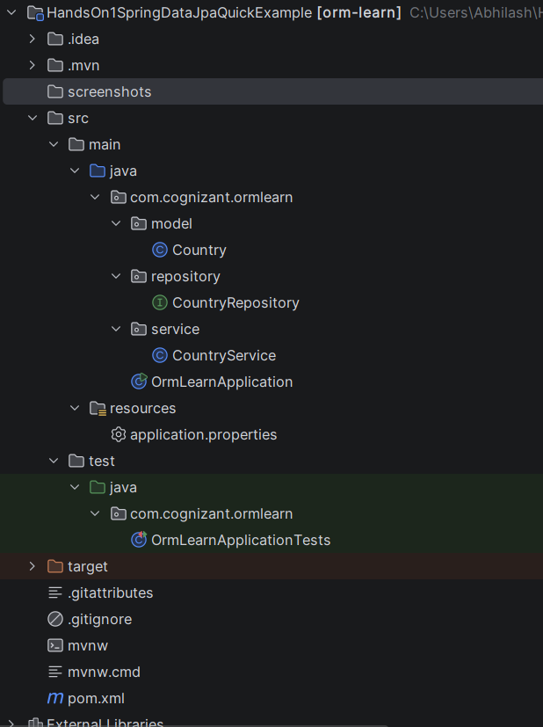

- MySQL Workbench (SELECT * FROM country)
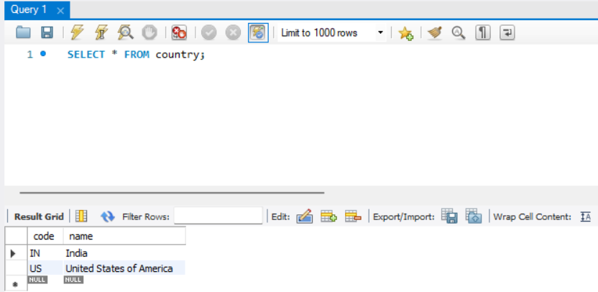

- application.properties (optional but recommended)
